# Employee Database User Guide

## Adding an Employee

An employee can be added by filling in the required fields for the selected type of employee and clicking the **Add Employee** button.

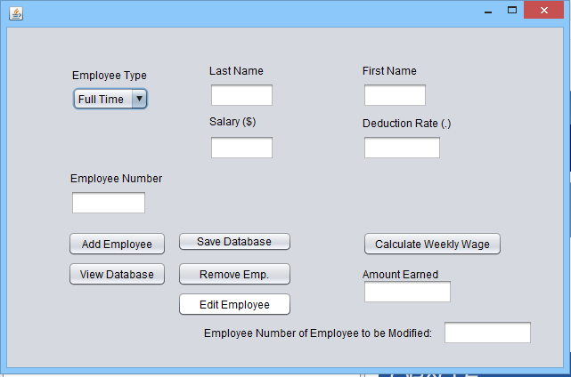

Selecting the **Full Time Employee** type from the dropdown box will bring up the fields required for a fulltime employee, whereas selecting **Part Time Employee** will bring up the fields required for a part-time employee.

Below is a sample of filling in the data for a full time employee.

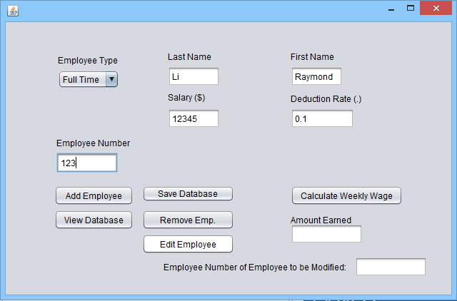

Below is a sample of filling in the data for a part time employee.

## fa.png

## Removing an Employee

An employee can be removed by typing the employee number in the textbox at the bottom righthand corner and clicking the **Remove Emp.** button.

C:\Users\RUHANLI\Desktop\ca64e7e530ca1ec757c896a9f784d2c5.png

fa.png

## Editing an Employee

An employee's information can be edited by typing the employee number into the textbox at the bottom righthand corner and clicking the **Edit Employee** button.

C:\Users\RUHANLI\Desktop\ca64e7e530ca1ec757c896a9f784d2c5.png

fa.png

## Backing the Data up

The data can be backed up any time by simply clicking the **Save Database** button.C:\Users\RUHANLI\Desktop\ffc8f092945439c7edf12499624b991a.png

Displaying the Data

The data can be displayed at any time by simply clicking the **View Database** button. This will prompt a popup box to pop up displaying the employees in the database.C:\Users\RUHANLI\Desktop\fa.png

The format for the outputted text is the employee type (F for Full Time, P for Part Time), followed by the employee number, employee first and last names, deduction rate, and the salary.

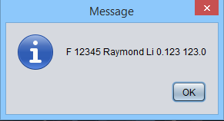

Clearing Text Fields

If the employee fields must be cleared for whatever reason, click the **Clear Fields** button.C:\Users\RUHANLI\Desktop\fa.png

Calculating the Annual Wage

An employee's annual wage by typing the employee number in the textbox at the bottom righthand corner and clicking the **Remove Emp.** button.

C:\Users\RUHANLI\Desktop\fa.png